Practical 6:

**Exercise 3:**

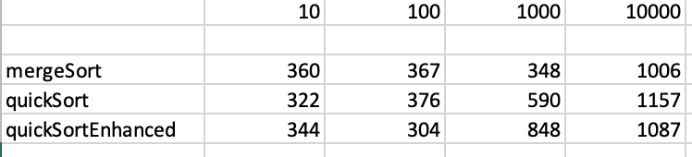

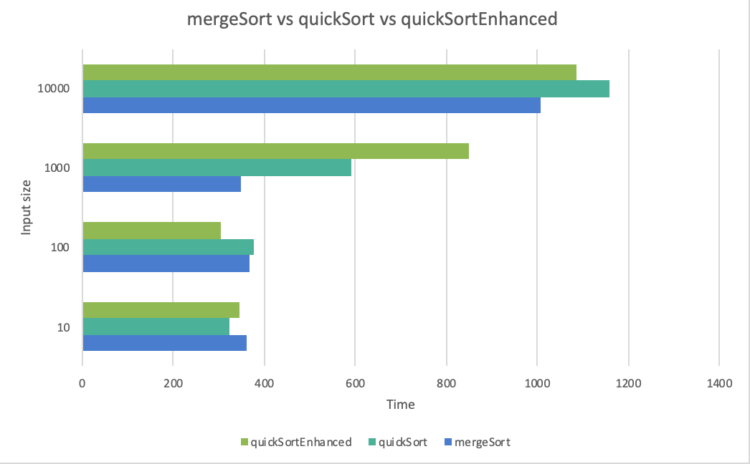

As we can see from the graph, mergeSort was faster for most of the input sizes. quickSortEnhanced was faster than quicksort for the input size 10 and 100. The worst case complexity for quicksort is O(n^2) as it takes a lot more comparisons in the worst condition and for mergesort it is O(n log n). From the results we can see that merge sort is more efficient for larger array sizes, where as quick sort is better at sorting smaller arrays. This is due to the fact that quicksort requires more comparisons for when the array size is bigger compared to mergesort when sorting larger arrays.